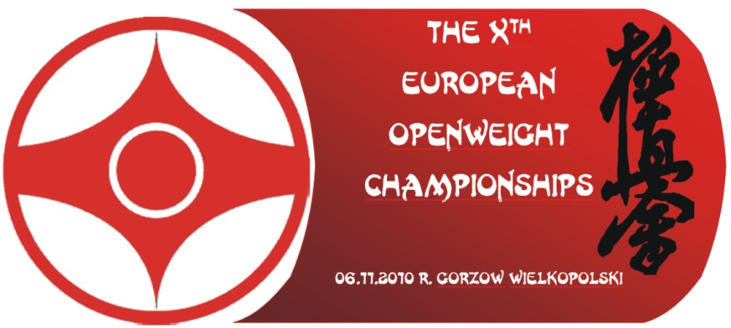

BULLETIN No. 2

Detailed Information Regarding

THE 10th EUROPEAN OPEN CATEGORY CHAMPIONSHIPS
GORZOW WIELKOPOLSKI 2010

We would like to inform you that the preparations for the Championships are going well. Poland TV will cover 1 an hour's report which remaining emitted on Sunday.

Patronage:
The patronage over championships took the President of the City Gorzow Wielkopolski and the Embassy of Japan.

Date of the Championships:
Saturday, November 6, 2010

Place of the Championships:
City Sports Hall
ul. Czeresniowa 1
66-400 Gorzow Wielkopolski

Official Hotel:
“Mieszko” Hotel ***
ul. Kosynierow Gdynskich 82
66-400 Gorzow Wielkopolski
Tel.: +48 95 733 9896
Fax.: +48 95 733 9898

Travel information:
The Organizing Committee advises everyone coming to Berlin Schoenefeld (best connection, only 130 km) or Berlin Tegel (170 km) or Poznan Lawica (in Poland, 120 km) Airports to use our free buses between Airports and Gorzow Wielkopolski.
Attention: Persons from outside the European Union must land only in Poland and must obtain Polish visa when required.

Each team may be composed of:
1. Country Representative
2. Coach
3. Fighters in open weight category (kumite men) – no limit of competitors
4. Fighters in open weight category (kumite women) - no limit of competitors
5. Fighters in open weight category (kumite men) over 35 years of age – no limit of compet.
6. Kata competitors – max. 4 men
7. Kata competitors – max. 4 women
8. Junior fighters in 3 weight categories: - 70 kg, - 80 kg, + 80 kg (kumite men) – max. 4 men born 1993, 1994, 1995
9. Junior fighters in 2 weight categories: - 55 kg, + 55 kg (kumite women) – max. 4 women born 1993, 1994,1995

Note:
Senior fighters must be over 18 years of age, minimum required grade is 4th Kyu.

Please consider that Country Representatives may act as referees, therefore it is necessary for them to have suitable outfit: dark blue shirt, black trousers, white bow tie, whistle, etc.

Please, remember that fighters may be subject to anti-doping test, as Polish Kyokushin operates under the supervision of the Sports Ministry.

Main Judge:
Shihan Antonio Pinero

Insurance:
The Organizing Committee, according to the Polish law, has insured the whole event. However, please make a personal insurance for you competitors in your own country.

Accommodation fees:
The accommodation fee is 85 € per person in double room, and shall be paid by each participant prior to registration at the Organizing Committee check-in desk in Official Hotel.
The fee including accommodation for two nights in “Mieszko” Hotel *** (bed, supper, two breakfasts, dinner, Sayonara party, transportation from/to Berlin and Poznan Airports and other organisational expenses).
Additional night: 25 € per person (in double room including breakfast).

The accommodation fee is 110 € per person in single room.
Additional night: 35 € per person (in single room including breakfast).
Additional ticket for Sayonara party: 20 €.

Deadline for hotel reservation: 1st of November 2010.

Costs of extended stay, room service, telephone, and other charges shall be incurred by the participants.

Officiating Team:
The EKKO participation fee for each competitor is 25 €.
Referees course: refreshing course free, judge exam fee is 50 €, referee exam fee is 75 €.
The above amount shall be paid to the EKKO treasurer Shihan Lars Hogquist.
There is no stamp fee any more.

Tickets:
Competitors and officials will receive special ID Cards.
Guest and spectators can purchase tickets for 5 €.

Visas:
If you need a Polish visa send at once an e-mail containing the following information: Full name, date of birth, passport number and function in the team. Additionally we do need address, telephone and eMail of the Polish embassy in your country.

Forms:
Please, fill in and send us the following forms:
1. EKKO Entry Form,
2. Room Booking Order Form.
3. Ticket Booking Order Form.
4. Arrival and departure Form (if you are in the Official hotel).
5. Personal Information Form for competitors.

Note:
All entries must be send to the General Secretary EKKO, and a copy to the Organizers:
- general.secretary@ Europeankyokushin.org
- sekretariat@osir.gorzow.pl

GENERAL SCHEDULE

THURSDAY 4th of NOVEMBER
- EKKO and KWF Boards arriving.

FRIDAY 5th of NOVEMBER
- Competitors arriving at the Official Hotel:
“Mieszko” Hotel
ul. Kosynierow Gdynskich 82
66-400 Gorzow Wielkopolski
Check-in time: from 2.00 p.m.

- Official Registration and Official Medical Check-up at Official Hotel:
from 3.00 p.m. to 8.00 p.m.

Please bring:
- National Passport and EKKO passport.
- Medical Certificate (in English).
- Personal information form.
- One I.D. photo (in gi).
- Your karate-gi.
- Personal insurance.

You will have to sign:
- Waiver Form
- Anti-doping test Agreement

You will receive:
- Zekken
- I.D.Card
- Championships Schedule.

Deadline of Competitors Registration 8.00 p.m.

- International Judging Course and exams:
from 4.00 p.m. to 6.00 p.m.

- Supper:
from 6.30 pm to 7.30 p.m.

- Departure by bus to Aqua Park & swimming pool:
7.30 p.m.
Do not forget to take swimming-panties

- Organizing Meeting (for CR and coaches)
from 8.00 p.m. to 9.00 p.m.

- Extraordinary General Meeting of the EKKO and KWF (only for members)
from 9.30 p.m. to 11.00 p.m.

- Computer Drawing: 11.00 p.m.

SATURDAY 6th of NOVEMBER
- Breakfast:
from 7.00 a.m.

- Depart Organizing Hotel for Sports Hall:
9.00 a.m.

- First Round Fights:
10.00 a.m.

- Opening Ceremony of the Championships:
4.00 p.m.

- Sayonara Party:
9.00 p.m.

SUNDAY 7th of NOVEMBER
- Breakfast:
from 7.00 a.m. to 11.00 a.m.

- Exam for the higher grades (1st to 5th dan) in the training gym.
10.00 a.m.

- Check-out:
12.00 a.m.

We are looking forward to welcoming you soon in Poland.

If there is anything else that we can assist you with, please let us now.

Official address:
Polish Kyokushinkai Organisation
ul. Kremerowska 3
31-130 Krakow
tel: + 48 12 634 1338
fax: + 48 12 632 5973
mobile: +48 601 421 145 (shihan Andre Drewniak)
Email: polish.kyokushin@karate.org.pl
Website: www.europeankyokushin.org
Organizer: sekretariat@osir.gorzow.pl

Osu,

Wlodzimierz Roj Andre Drewniak

Organizing Committee Chairman President Polish Kyokushinkai Organisation

