TICKET BOOKING ORDER FORM

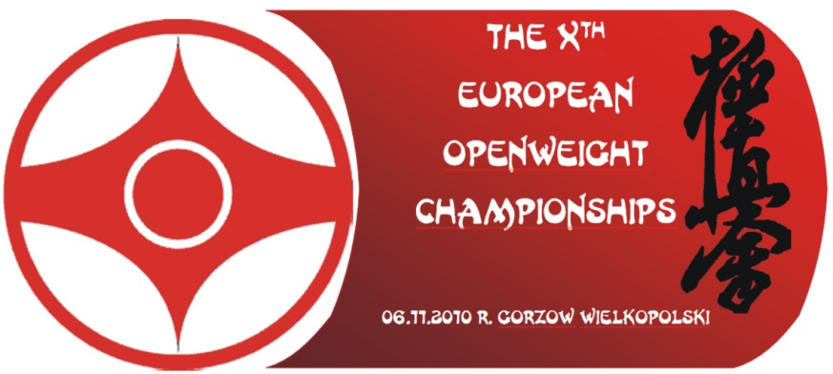

COUNTRY:

Please, book entry tickets for the 10th European Championships – Gorzow 2010

 | PRICE | QUANTITY | TOTAL PRICE IN PLN
All the day | 20 PLN (app. 5 EUR)
Finals | 15 PLN (app. 4 EUR)

I am obliged to purchase all booked tickets from the Organizer at the Official Hotel on November 6th
before 9 p.m. In case of my resignation I am obliged to notify the Organizer before November 1, 2010.

Data ……………… Country Representative: ……………………………..
signature

